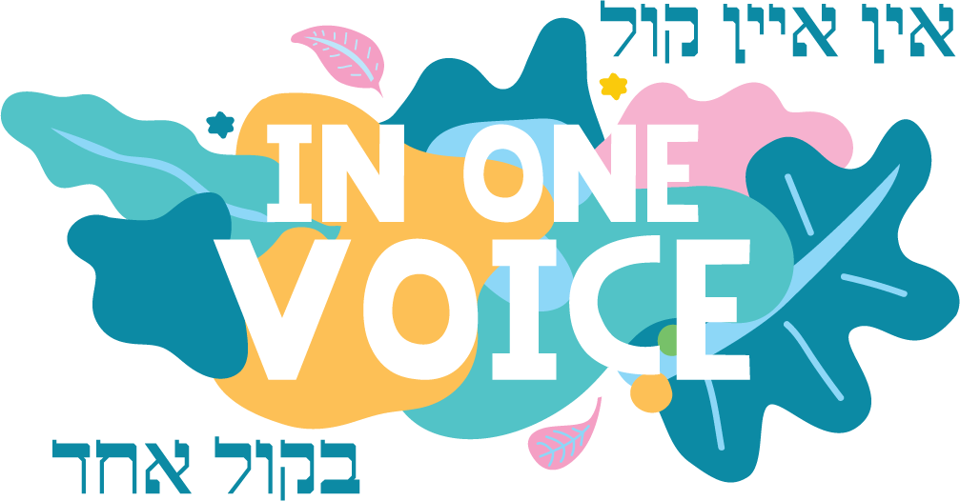

w: inonevoice.org.au
e: withonebrush@gmail.com

WITH ONE BRUSH ENTRY FORM
EXHIBITOR DETAILS
Name of Artist
Address
Contact Numbers
Email Address

ARTWORK DETAILS
Artwork Title | Type  (Painting, Photography, sketching, drawing, sculpture etc.) | Size of Artwork  (approx.) | Sale Price  ($)
1.
2.
3.
4.

WITH ONE BRUSH: TERMS & CONDITIONS
- An exhibitor may enter up to a maximum of five (5) artworks.
- Painting and print works should be suitably finished and ready for hanging, provided with screw eyes and hanging wire. Contact details (name and contact number) must be clearly labelled on the back of each piece of artwork.
- Photos of artwork together with this completed application form must be emailed to withonebrush@gmail.com by 28 February 2021.
- A handling charge of $15 per piece, or $25 for two pieces is required to be paid by the exhibitor to help cover the cost of screen hire, advertising, printing etc. Payment in full must be made prior to delivering the artwork.
Payment is to be made by buying a ticket per submission at the below TryBooking website:
https://www.trybooking.com/BOWMS

- All artwork must be delivered to the IOV Festival at Sholem Aleichem College Elsternwick, 11 Sinclair Street Elsternwick 3185 between 9:30am and 12.30pm on Friday 19th March, 2021. The Art Exhibition will be held in the industrial chic surrounds of the former ABC site in Selwyn St, Elsternwick. Arrangements will need to be made for anyone who cannot deliver on this day by contacting Nastassja on 0478 023 155.
- Unsold works must be collected by 4 pm on Sunday 21st March 2021 from the exhibition site. Any works not collected will not be covered by insurance and no responsibility will be taken for any loss/damage.
- Transport of works to and from the Exhibition will be the responsibility of the artist, and will be at his/her cost.
- The Organisers will exercise all reasonable care in handling the artworks accepted, but will not be responsible for the loss of or any damage to any works while in the custody of the Organisers. Insurance against damage, fire and theft on individual works whilst in the Organiser's custody or in transit is the Artist’s responsibility.
- PLEASE NOTE: The organisers reserve the right to reject any work, and no correspondence regarding their decision will be entered into. In such instances, handling charges will be refunded.
- The organisers reserve the right to display the submitted works throughout the duration of the exhibition in such manner as they may choose. No discussion or correspondence will be entered into on this point.
- The Artist appoints the Organisers as his or her agents for all purposes associated with the exhibition and agrees to allow the Organisers to offer all artworks for sale to the public at the price stated by the Artist on the entry form, unless specifically stated that the artwork is not for sale.
- The Organisers will deduct 25% commission plus GST (i.e. 27.5% incl. GST) from all artwork sales.
- Artists will be paid within 14 days of the closure of the Exhibition.
- The Organisers shall have the right to photograph paintings and publish those photographs for publicity purposes.
- All accepted artworks will be eligible for a $1000 prize award. The Organisers’ and Judges' decisions are final.

I hereby agree to the above Terms & Conditions of the “With One Brush” Art Exhibition
Name: _______________________________
Signature: _______________________________
Date: _______________________________

