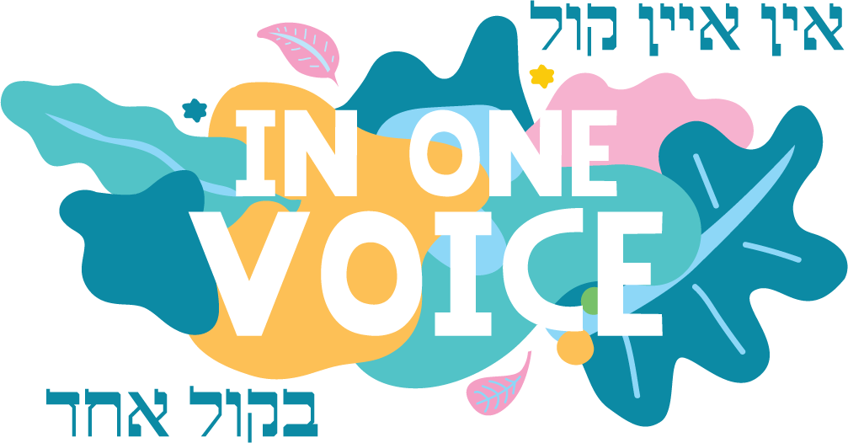

w: inonevoice.org.au
e: withonebrush@gmail.com

Dear Artist,
The “In One Voice” (IOV) Jewish Street Festival is proud to announce the return of the “With One Brush” Art Exhibition which will take place on Sunday 21st March 2021.
As an Artist you will be given the opportunity to sell your artwork and the price of your artwork will be at your discretion. Please note, selling your artwork is not a compulsory requirement.
Works may be 2D or 3D i.e. -paintings, photography, drawings, digital works or sculpture. All 2D artworks must be ready to be hung on the day. There will be a $15 fee per piece of artwork.
We are excited to also announce that a prize of $1000 will be awarded to the top piece of artwork as judged by our panel of professional artists.
To participate in this exhibition please buy tickets at TryBooking link in the application form ($15 per piece, or $25 for two pieces submitted ), complete the attached application form and email it together with a photo/s of your artwork to the Committee at withonebrush@gmail.com by Friday 28th February, 2021.
If you have any questions, please email withonebrush@gmail.com . After hours you can call Nastassja on 0478 023 155 or Aviva 0413 540 273.
We look forward to hearing from you and receiving your application to participate in this exciting Art Exhibition in 2021.
Regards,
Nastassja & Aviva
With One Brush Art Exhibition Coordinators

